DEVIOUS WORDS #1
Devious Words is a tricky puzzle for wordplay lovers and strategic thinkers alike. Four magnetic cubes - each covered in tantalizing bigrams - hold the key to unlocking 12 hidden words. Twist, rotate, and align the fragments to form words, but be warned: every move matters. With countless word combinations and endless possibilities, only the most cunning minds will decode them all.
Devious Words is part linguistic challenge, part spatial puzzle, and 100% addictive. Whether you're a casual word game fan or a seasoned puzzler, each Devious Word game will stretch your brain in ways you never saw coming.
Ready to crack the code?
When correctly aligned, 12 four-letter words will be found in six spots: four along the outside edges, four on the front and four on the back. The front and back words are found in two directions: left to right and top to bottom.
For example, left to right are found NONE and SEAT, while from top to bottom are found NOSE and NEAT. | 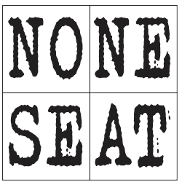
Find hints and the solution at www.BRAINY.games

